Adventures with Eve
Brynn McGuire

I always wanted a puppy of my own. We always had Blair, my mommy’s Chesapeake, and then she got another Chesapeake puppy, Nash, when I was almost seven. But I wanted my own dog so I could show her in dog shows since Blair was too old and Nash was too young. Mommy kept saying wait! I had to wait until I was old enough to enter Junior Showmanship, then she said we had to wait until we found the right puppy. She said we were thinking about two different Chesapeake puppies and I worried we would pick the wrong one, but when she said we were going to get a puppy from her old friend, Mitch, I knew this would be the perfect puppy. I even dreamed of winning Best in Show with my puppy!
The day before I met my puppy, who I planned to name Eve, my mommy and I got on a plane. Then I had to wait for everybody to find their seats, for a baby to stop crying, and me to be able to fall asleep because it was really early in the morning. Then I had to wait for food, for another plane, and for a rental car. But then we were finally in Maryland. We got to the breeder’s house and I was so excited that I ran right inside and I saw Eve! She jumped as high as she could when she saw me, so I went into the puppy playpen and sat down with all the puppies, but Eve climbed on my lap and we both fell asleep. We both just knew she was mine and I was hers. I had to leave her so we could get in the breeder’s big truck and go eat tacos, but I couldn’t wait to get back to my puppy. She had to sleep downstairs with her litter while we slept upstairs, but I was too excited to sleep. In the morning after I saw Eve, we got back in the big truck to go eat, and later I got chocolate ice cream with sprinkles.
Finally I got to take my puppy! We went to the beach, because Chesapeakes love water, and Eve was so excited and loved it when I put her in the water. I love Maryland because we used to live there and I miss my school, but we got to eat crab for dinner which was amazing. We stayed in a hotel, but Eve didn’t like it and she just cuddled up with me and licked my face. When we got to the airport, we went to get Eve’s ticket but they said my big beautiful puppy was too big for her carrier! A lady offered to get us a bigger one but she didn’t come back. It was late and we didn’t know what to do, and I was afraid we would have to leave Eve in Maryland, and mommy and I started crying and crying. But then Mommy found another airline and they were really nice and said she could go and I was full of joy because we made it. I had to do more waiting for the plane, and to take care of Eve at the gate, and to walk back to the car, but I was cheerful because I had my puppy!
Having a best friend in your house means she wants to be first with me. She just goes crazy when I come home from school or cheer because we love each other. When I’m sad, she knows. When I’m upset, I just take her outside and play with her, or if it’s too hot, I will just lie down in her crate with her. Eve tries to comfort me and licks me and I hug her until I feel better. I do Allstar Cheer and at my gym it was really hard because I felt like I had to be perfect all the time. The coaches kept yelling at me, no matter how hard I practiced, and I lost all confidence and all my energy so I couldn’t do the stunts I used to do. But I was able to push through that because I knew I was going home after practice and I could see Eve. Finally we moved to a different gym that was much better. Eve was like a therapy dog and helped me get through that and now I love cheer again!
Eve needs me to comfort her sometimes too, like when she does something wrong because she’s a puppy. It’s like a giant circle of love between us. We just look at each other and we can feel it, because we are best friends. Getting Eve was definitely worth all the waiting.
Dreams really do come true. I did take Eve to dog shows, and she finished her AKC Championship and her UKC Championship, and I also won lots of ribbons with her in Junior Showmanship, just the way I’d hoped. It feels really good and Eve knows when the judge points to her, and we did it together. With Eve at dog shows, I felt like I conquered something, unlike cheer used to be, and I felt like Eve and I were valuable. When I win, my confidence goes up. I used to be too scared to show what I could do, but Eve helped me to not be scared and to show what I could really do, at dog shows and at cheer. I’m 10 now and we are still showing. My goal is to spend as much time with Eve as possible, because we are so happy together.
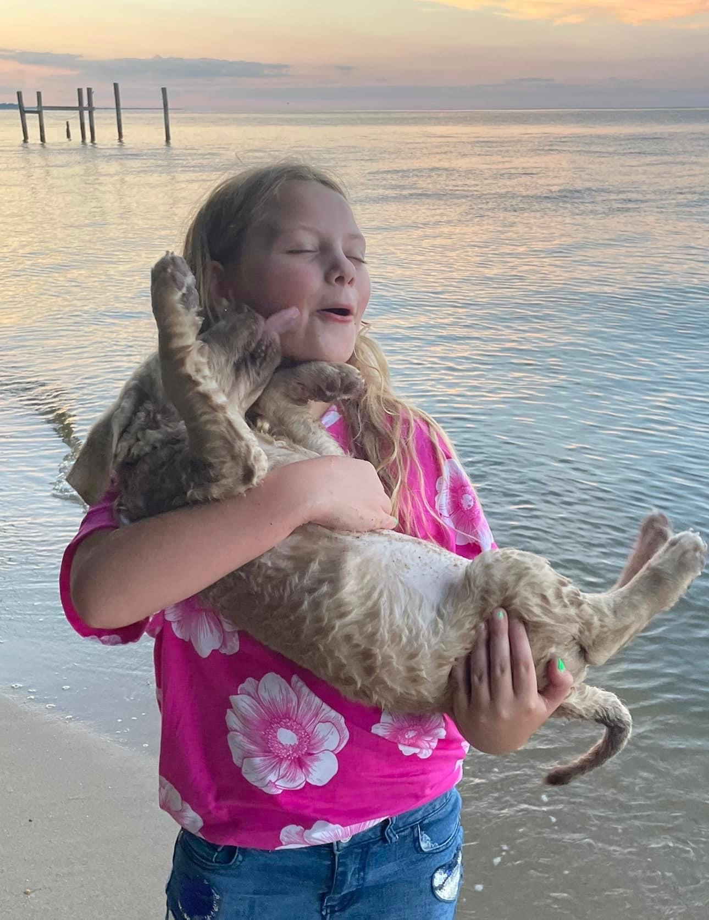
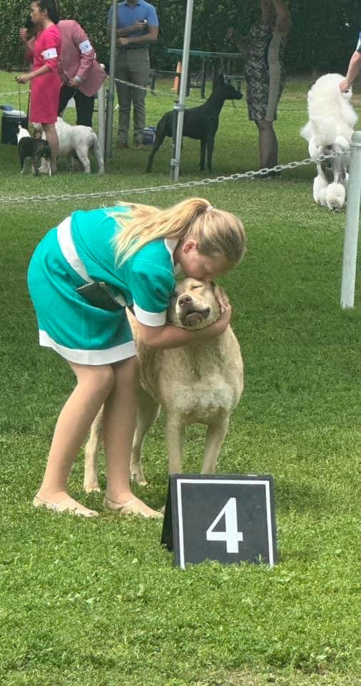
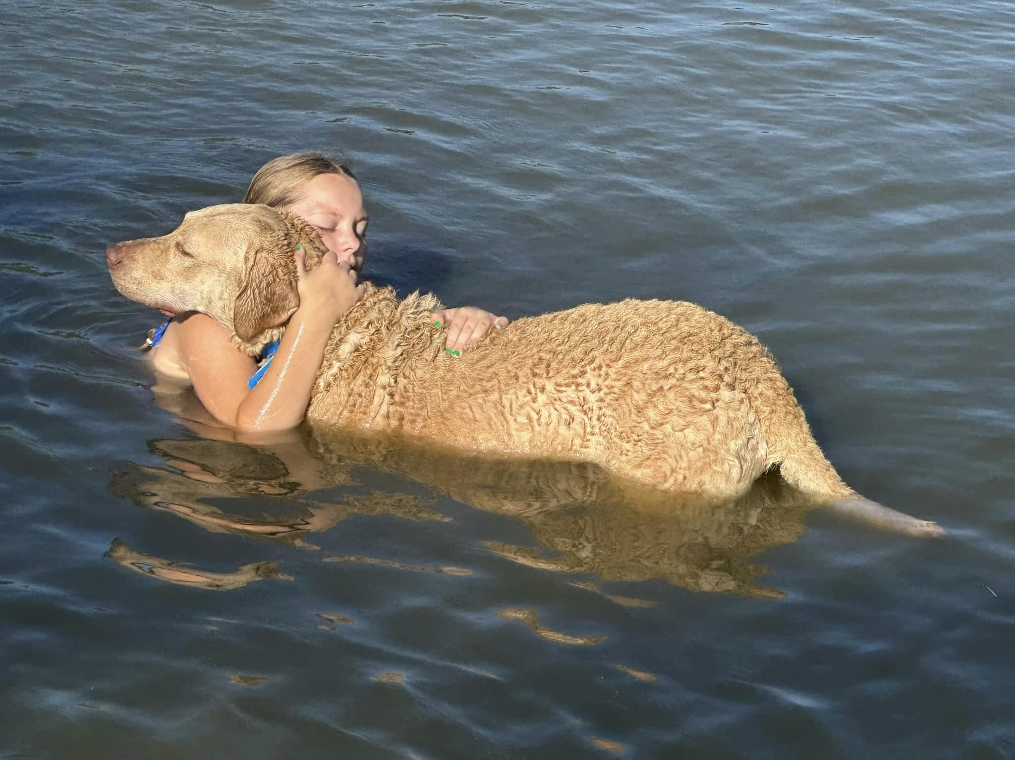
Look at our great new sign!
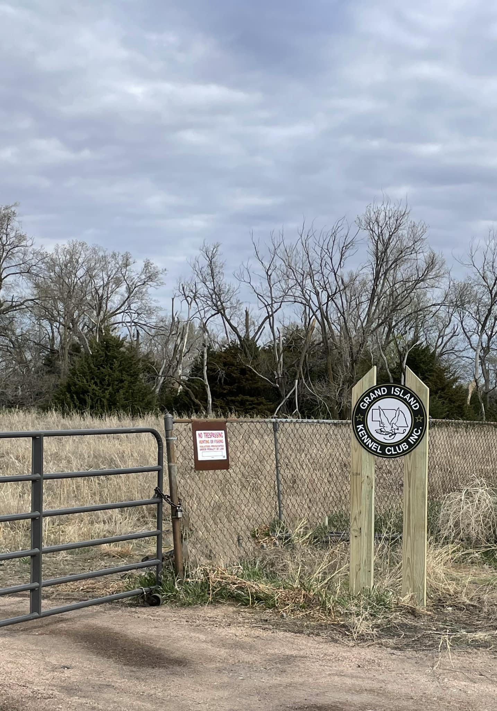

Thanks Doug for your contribution! Now it’s easier than ever to find our Club!

Upcoming Club Events

***New Classes starting the week of 7/31/23

Puppy
Beginning Obedience
Intermediate Obedience

Enroll online at gikennelclub.com

***Puppy Evaluations 8/2/23

Erin will be bringing her litter of bullmastiffs for evaluation at the clubhouse. Everyone is welcome!

***2024 GIKC SHOW

It takes a lot of planning and work to put together our awesome annual show. Contact our chair,
Tressa, to volunteer!

